[E135] Low voltage power supply

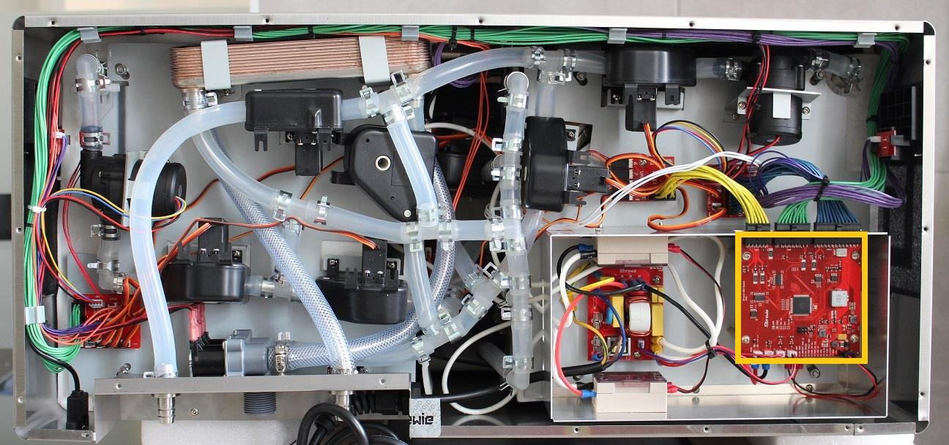

The low voltage power supply is located under the MCU panel. To replace the power supply, first the MCU has to be removed. The full procedure of removing the MCU can be found under the error code [E120].

After MCU removal unscrew the marked fastening screws and disconnect the cables to the power supply.

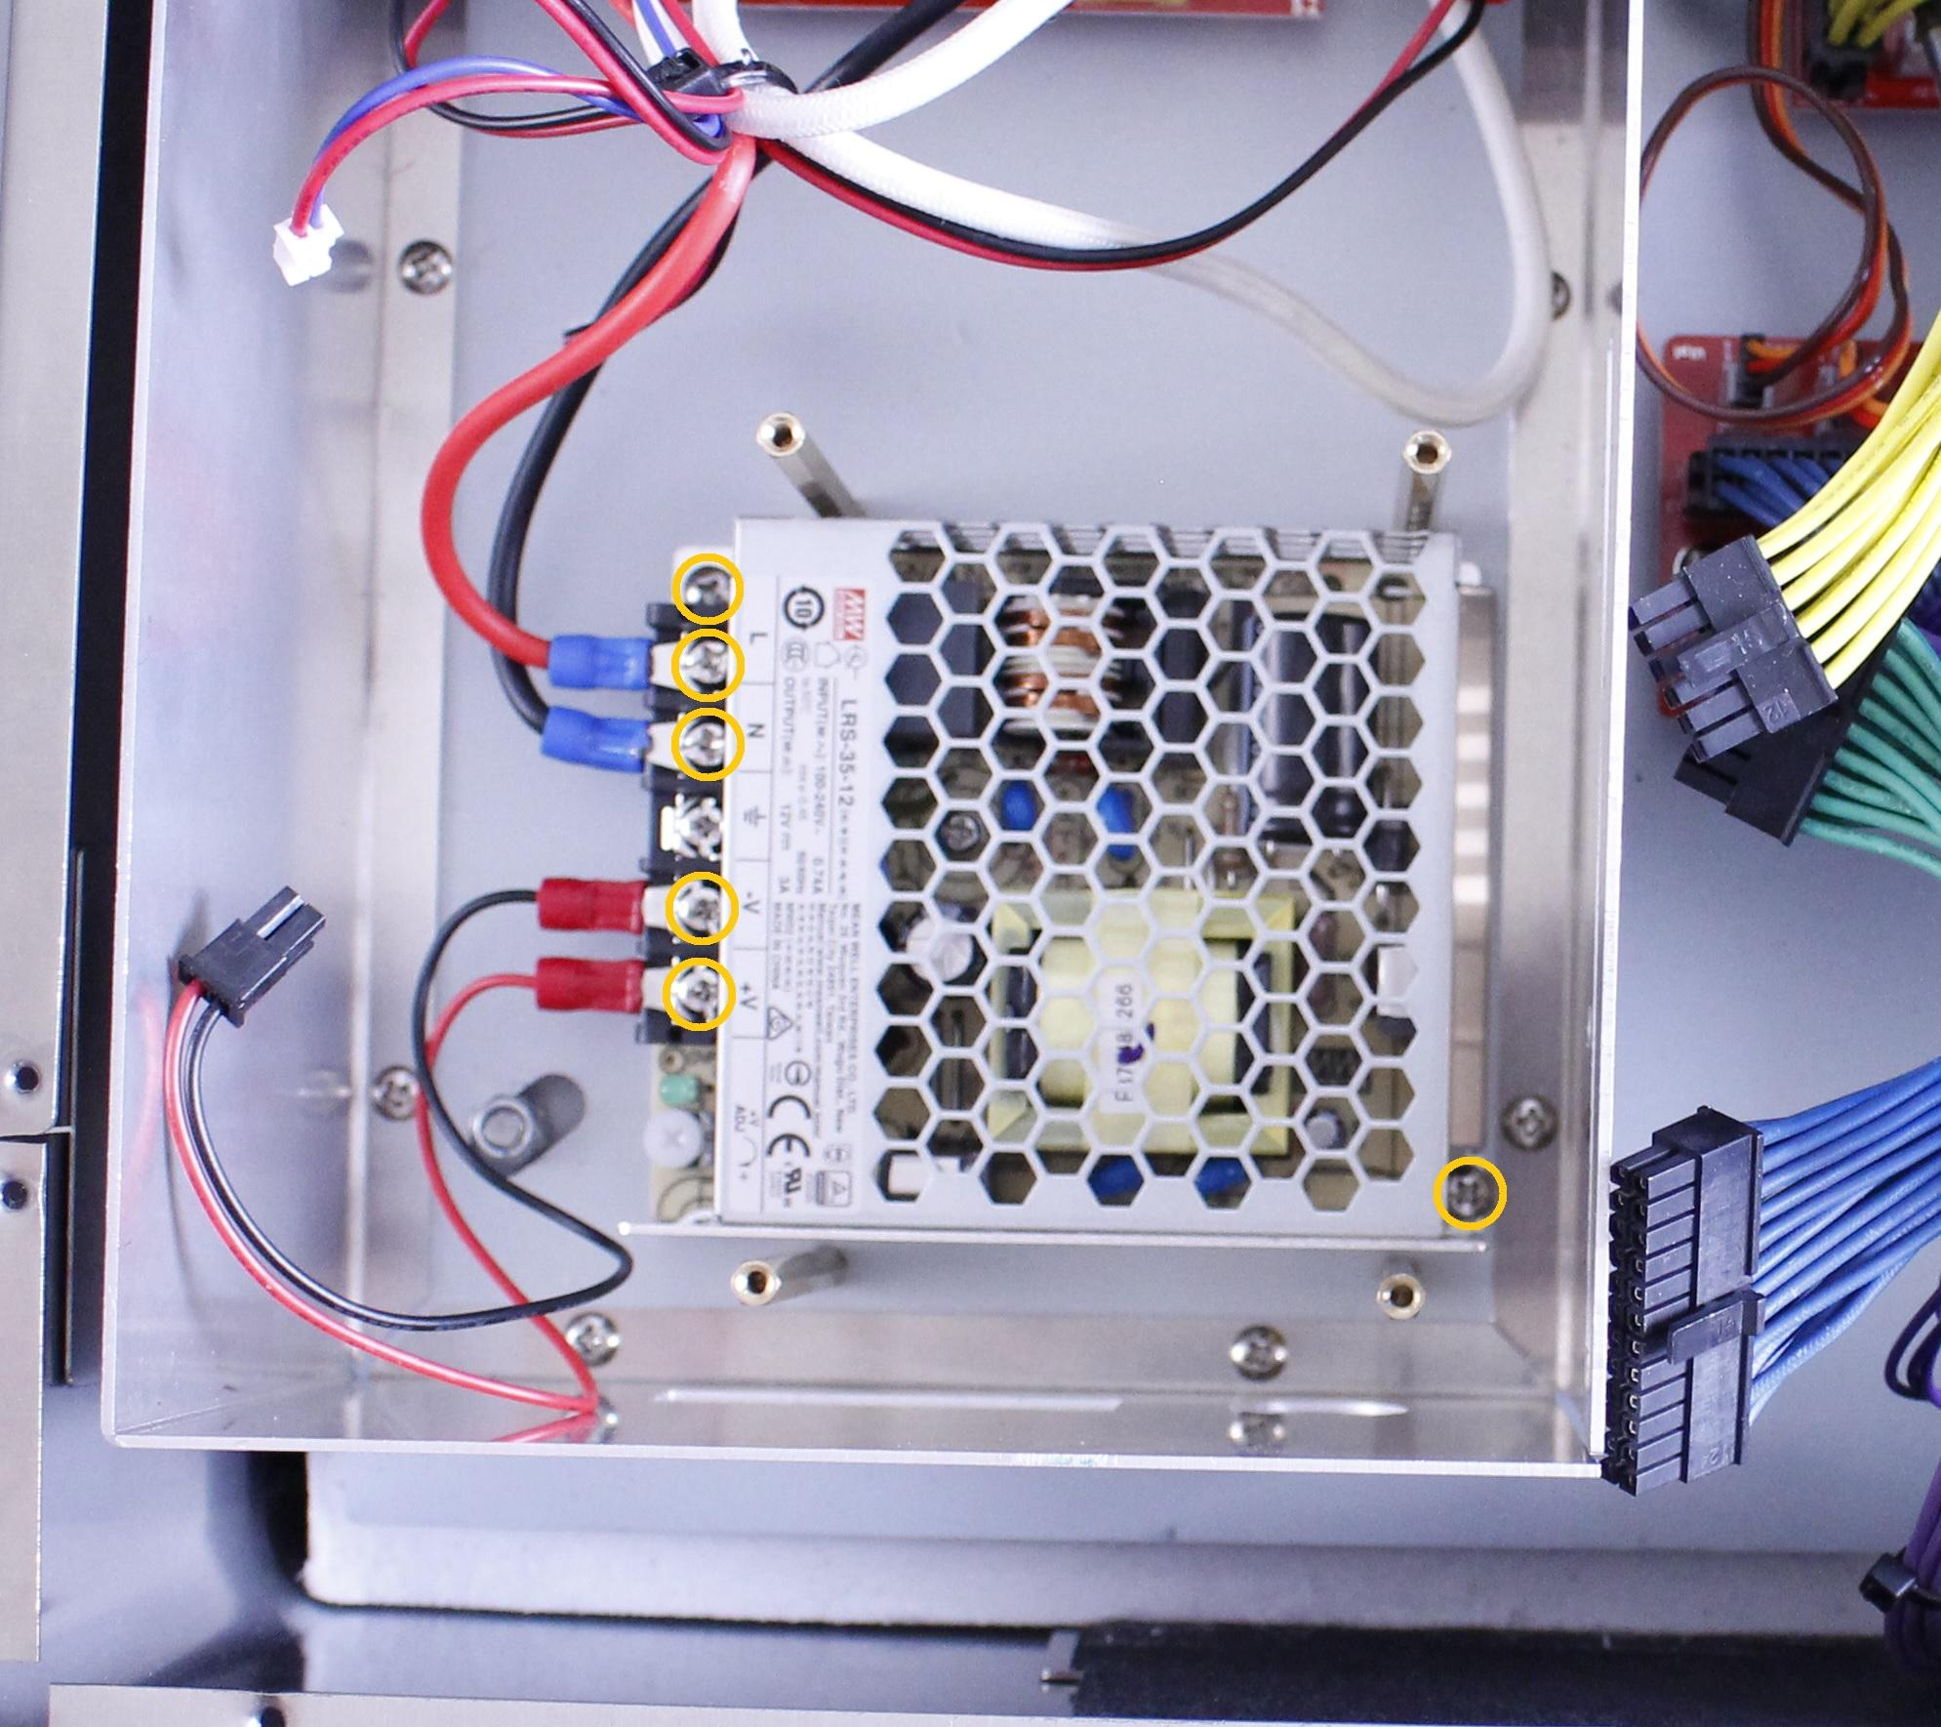

The power supply can be removed now.

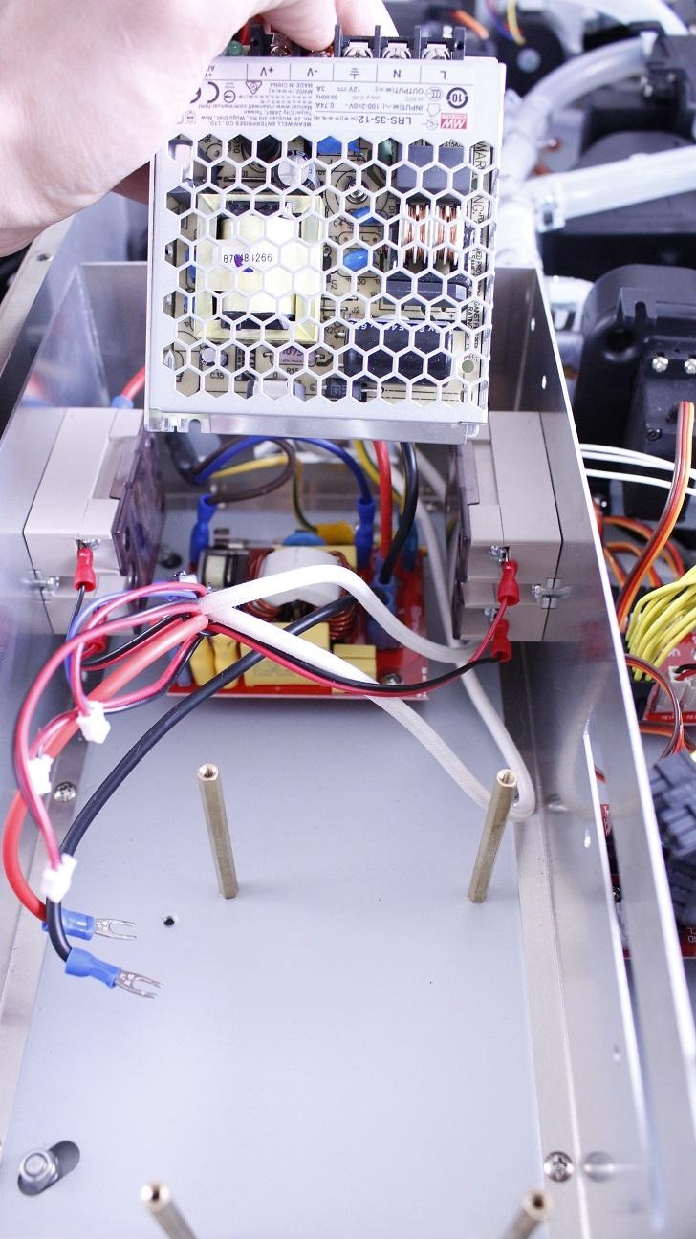

Reassemble consists of the same steps in reverse.